### **Write the python program to implement Minimax algorithm for gaming**

### **AIM**

To implement the **Minimax algorithm** in Python to determine the optimal move for player "O" in Tic Tac Toe.

### **ALGORITHM**

1. Represent the Tic Tac Toe board as a 3×3 grid.
2. Define functions to:
   1. Check if a player has won (is_winner).
   2. Check if the board is full (is_full).
3. Implement **Minimax**:
   1. If "O" wins → return +1.
   2. If "X" wins → return -1.
   3. If draw → return 0.
   4. Otherwise, recursively evaluate all possible moves for maximizer and minimizer.
4. Use best_move to select the move with the highest score for "O".
5. Output the best move coordinates.

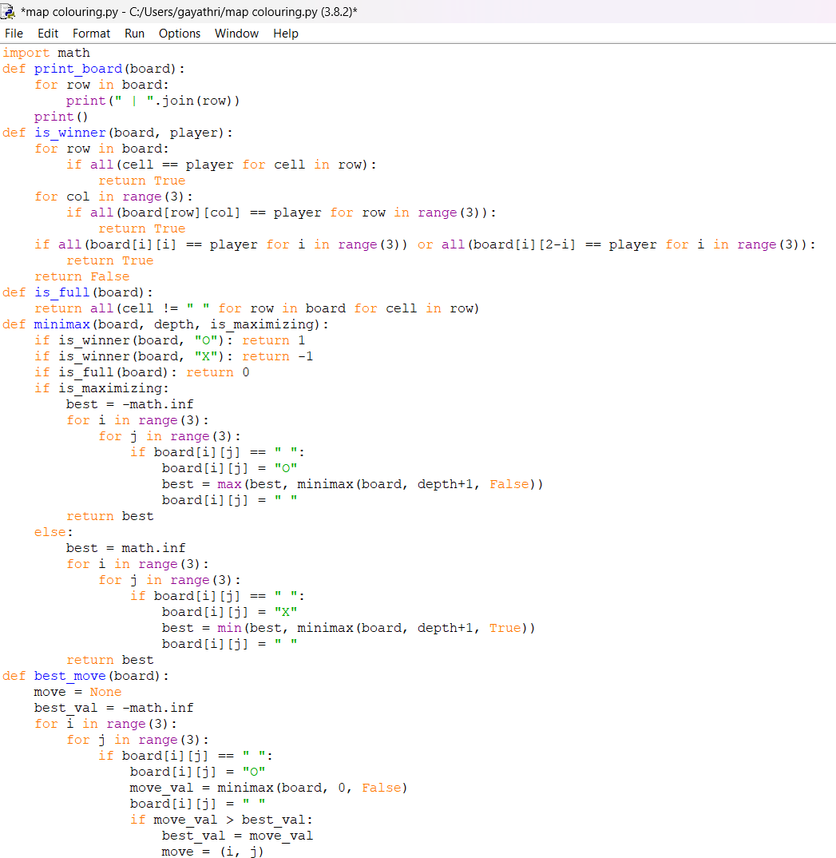

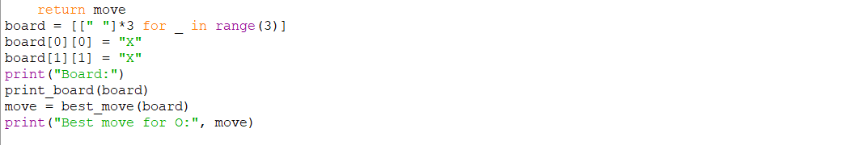

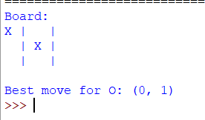

### **RESULT**

The program successfully evaluates all possible moves and selects the **optimal move** for player "O".